**使用電腦時的正確姿勢與設備**

**Correct Posture While Using a Computer**

**A 顯示屏幕的最頂適宜在略低於眼睛的水平，而位置應保持最少 50 厘米距離。**

**Eyes should be slightly above the top of the screen and kept at least 50cm away from the screen.**

**B 坐姿要挺直和貼近工作枱。**

**Sit upright and close to the desk.**

**C 前臂與手臂約成直角放於座椅手靠，鍵盤前面應留有足夠的空間來承托雙手。**

**Upper arms hang vertically with lower arms rested on the desktop. Enough space in front of the keyboard should be left to support hands and wrists.**

**D 在操作鍵盤時，手腕必需保持平直。**

**Keep wrists straight when keying.**

**E 將滑鼠放在適當位置，確保使用滑鼠時手腕平直。**

**Position a mouse within easy reach so it can be used with a straight wrist.**

**F 工作枱面下要有足夠空間容納雙腿活動。**

**Legs should have enough rooms to move under the desk.**

**G 為減少座椅邊對大腿背面及膝蓋的壓力，使用圓邊或渦形座墊的椅子較佳。有需要時，可使用腳踏改善情況。**

**Choosing a chair with round edge or curved cushion can avoid excess pressure from the edge of a seat on the backs of legs and knees. A footrest may be helpful.**



Student Health Service Web Site: www.studenthealth.gov.hk

***學務處衛保組關心您的眼睛Health Devision Reminds***

**護眼操Eye Exercises**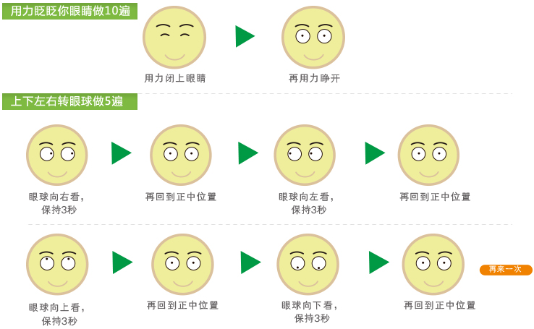

**再回到正中位置**

**再回到正中位置**

**上下左右轉眼球,做5遍**

**再來一次**

**再回到正中位置**

**眼球向下看,保持3秒**

**眼球向上看,保持3秒**

**眼球向左看,保持3秒**

**眼球向外看,保持3秒**

**再回到正中位置**

**用力眨眨眼睛,做10遍**

**再用力睜開**

**用力閉上眼睛**

<http://www.liangshili.cc/secret/>

**護眼撇步Tips for Eye Protection**

1. 使用智慧型手機時，應將手肘打直，維持30～40公分距離，約在視線平視15度下方。

Hold your smart phone at a comfortable distance of 30 to 40cm with a straight elbow, looking down at the screen at about a 15 degrees angle.

1. 避免將手機放置在桌上，低頭猛滑。

Avoid placing your phone on the desk and tilting over surfing or reading.

1. 用3C產品一小時應該休息10～20分鐘。

Take 10 to 20 minutes rest after one-hour usage of 3C devices.

1. 避免在黑暗中直視3C產品。很多人在睡前，一片漆黑中，使用手機瀏覽社群網站朋友動態，或是玩App遊戲。

Avoid looking directly at 3C devices in darkness. Many people surf internet or play APP games before bedtime in darkness.

1. 做**「護眼操」Exercise your eyes.**

***學務處衛保組關心您的眼睛Health Devision Reminds***